**Question 01**

**Q1 a)**

Our state-of-the-art weather app designed to provide you with accurate and reliable information on current and upcoming weather conditions in your area.

Our app features real-time data, customizable settings, interactive radar maps, and severe weather alerts to help you stay safe and prepared. With a user-friendly interface and intuitive design, our weather app is the perfect tool for staying informed about the weather, no matter where you are.

**Q1 b)**

The goal of a weather app is to provide users with accurate and up-to-date information on current and future weather conditions in their area.

The main objectives of a weather app are to offer users easy access to real-time weather data, forecasts, and alerts, as well as provide a user-friendly interface for visualizing and understanding the data.

Additionally, weather apps may aim to provide users with customization options, such as selecting preferred units of measurement, setting notification preferences, and personalizing the app's interface to suit their needs.

Overall, the goal and objectives of a weather app are to help users plan and prepare for weather conditions in their area and to stay safe during severe weather events.

**Q1 c)**

Our weather app is a software application designed to provide users with up-to-date information on weather conditions such as:

1. Temperature
2. Precipitation
3. Wind speed and direction
4. Humidity, and
5. other meteorological variables.

The scope of our weather app is general and target audience is general public.

**Q1 d)**

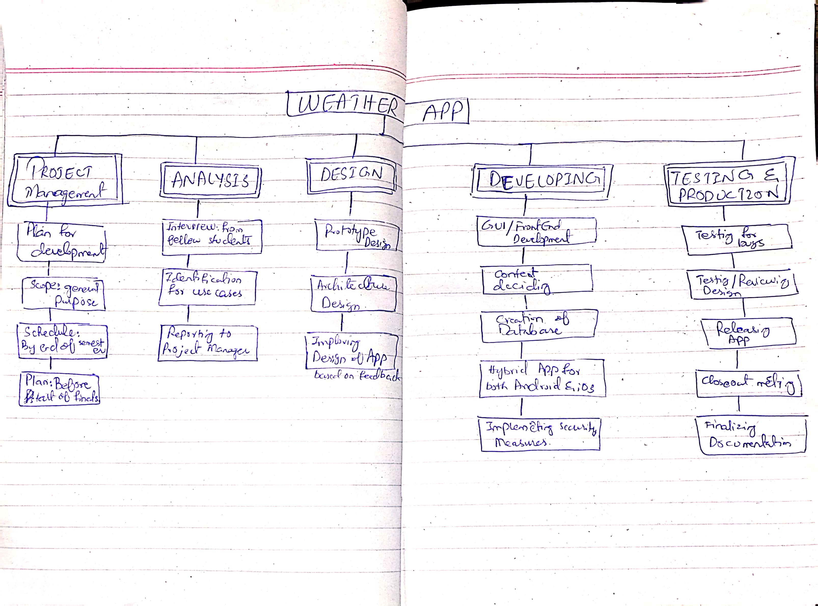

**Question 02)**

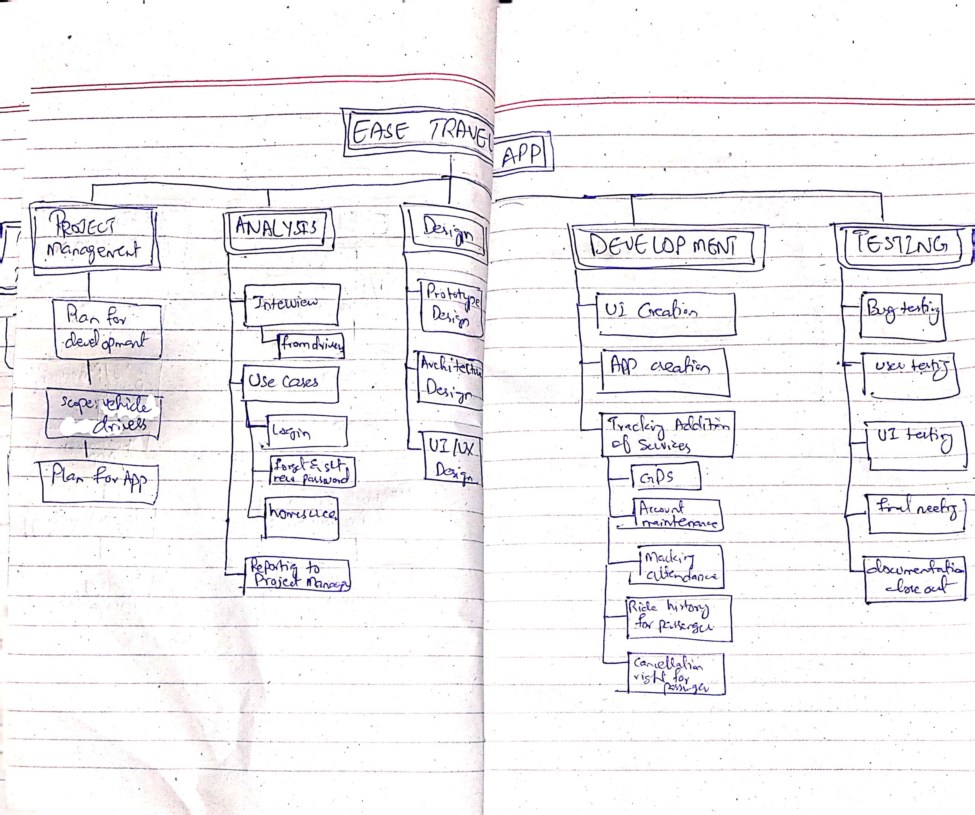

**Question 03)**

